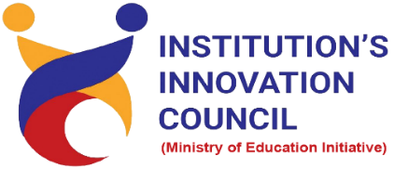

How to Plan for Start-up: Legal and Ethical Steps
11 May 2022
At
Virtually on Webex
Saurashtra University Campus, Rajkot
Contents
Saurashtra University – IIC 2
Event Schedule 2
Event Registration Link 2
Brief about Event 3
Key Points 3
Outcome 3
About the Speaker/Chief Guest 4
Connect Us: 5

Saurashtra University – IIC
The university is dedicated to instruction, research, and extending knowledge to the public (public service). Ministry of Education (MoE), Govt. of India has established ‘MoE’s Innovation Cell (MIC)’ to systematically foster the culture of Innovation among all Higher Education Institutions (HEIs). The primary mandate of MIC is to encourage, inspire and nurture young students by supporting them to work with new ideas and transform them into prototypes while they are informative years. Saurashtra University is one the Organization that have constituted the IIC to foster the vision of MoE and be a part for the promotion and development of innovation ecosystem.

Event Schedule

Event Registration Link

bit.ly/SLES-SUSEC

Brief about Event
We are organizing the Session on " How to Plan for Start-up: Legal and Ethical Steps" via Video Conferencing Mode to understand the process of Start-up and Multiple stages of start-up, an informative session to understand the start-up design is organized by SUSEC & IIC - Saurashtra University.
The webinar’s objective is to gain insights in a start-up thinking process to carry out some form of start-up. This involves what is start-up, Process of start-up registration, Legal aspect of start-up with various example etc. In this session also understand many compliances under mandatory laws like companies Act, income tax Act, GST Act, contract Act, legal metrology Act, foreign investment laws etc.
Also, understand central and state government incentives in start-up. In this session, discussion about start-up responsibility towards government, investors and social responsibility. In India, total more than 14000 start-ups have registered in 2022.

Key Points

During the session, below mentioned points were discussed:
- Definition of start-up
- Multiple stages of start-up
- Process of start-up registration
- Legal aspect of start-up
- Start-up growth rate in India
- Start-up responsibilities
- Top start-up in India
- FAQs related to How to Plan for Start-up: Legal and Ethical Steps

Outcome

As per the event, various types of start-ups, Importance of start-up and Ideation was understood by the speaker.
Also, as it was related to start-up responsibilities, start-up growth and awareness creation, a basic knowledge of how start-up process, how it works, how to develop start-ups, with various examples etc.

About the Speaker/Chief Guest

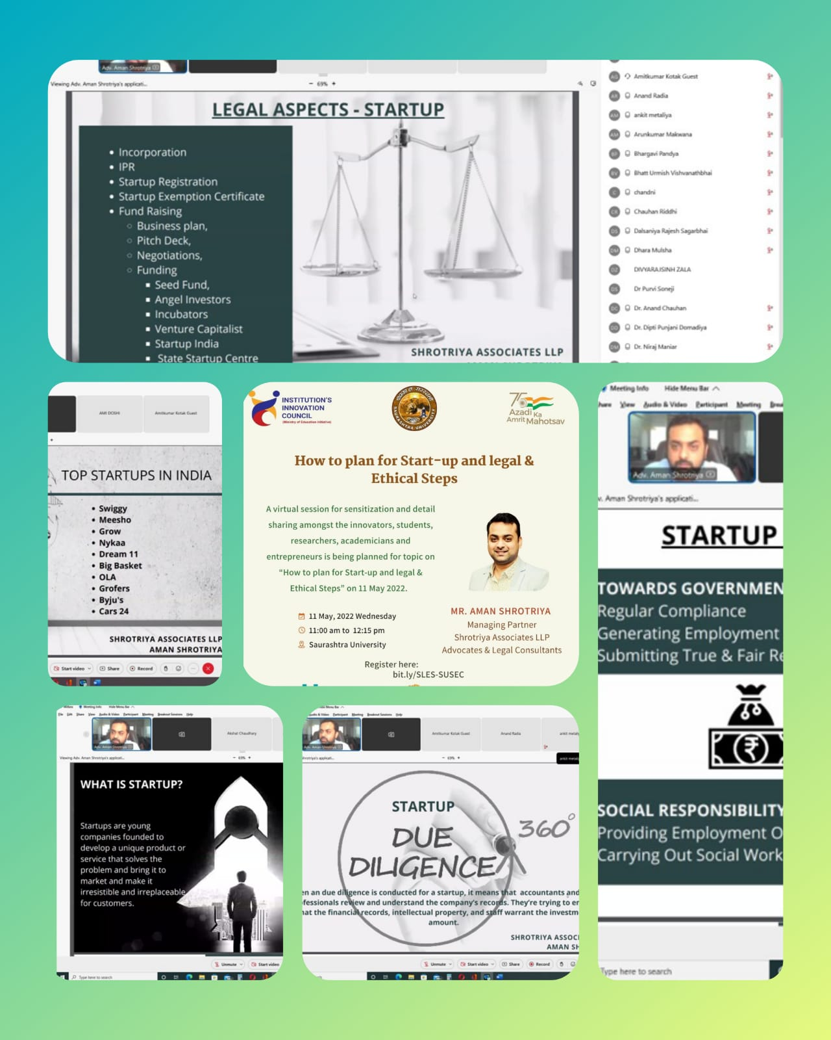

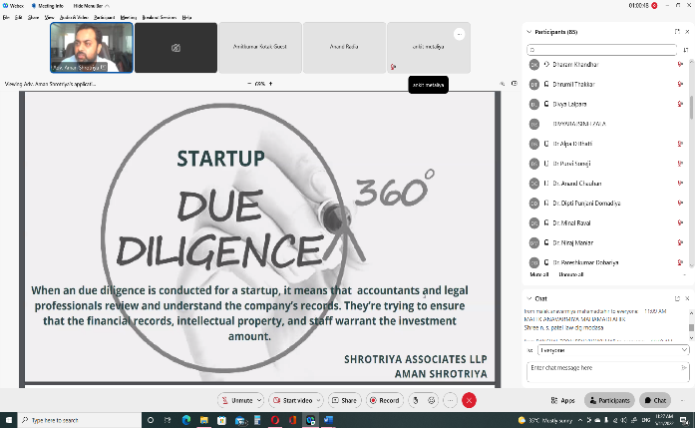
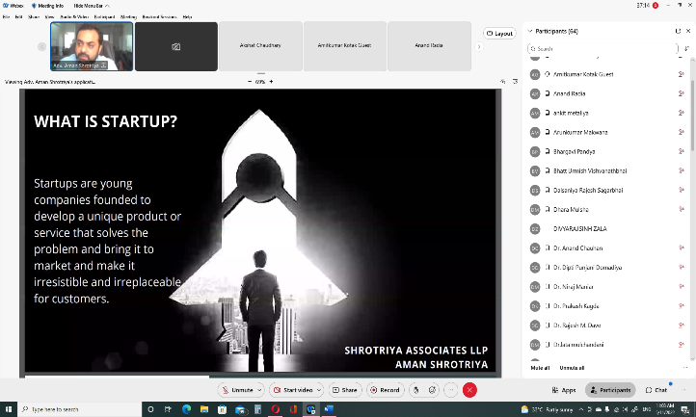
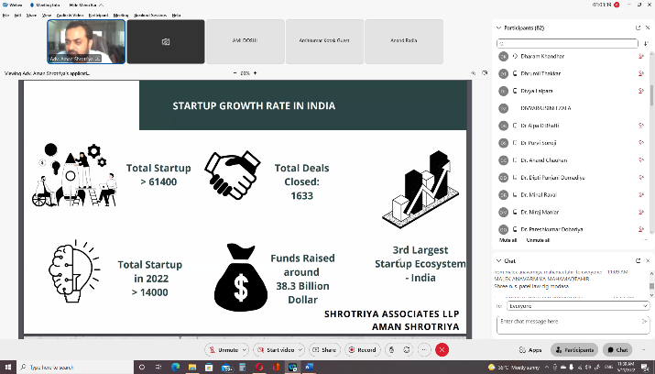
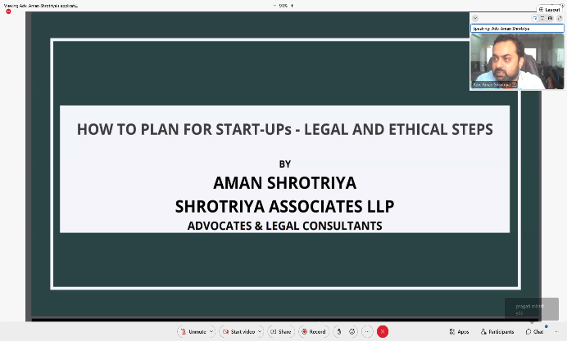

Connect Us:

https://www.linkedin.com/company/susec iic@sauuni.ac.in
https://www.facebook.com/iicsauuni bit.ly/SU-SSIP Location
https://www.instagram.com/susecrajkot

